

**The Harthaven Herald**

**Spring Edition - 2020**

**“if you don’t know where you are, you don’t know who you are.” Wendell Barry**

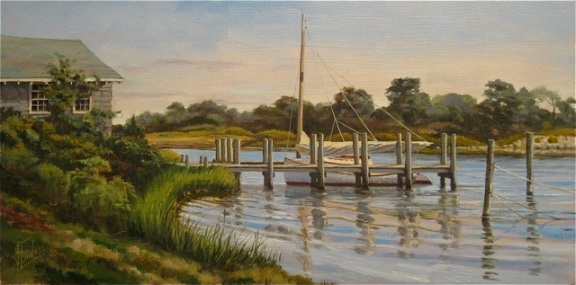

**A Corona Spring**

**By Sam Low - editor/publisher**

*Our response to the Corona Virus, individually and as a community and nation, has taught us a lot about the meaning of the word “home.”  And in a small community like ours in Harthaven, I think these lessons are particularly poignant. I asked some of you to compose essays about your Corona Spring and you have risen to the occasion with warmth, depth and thoughtfulness by describing how you turned to activities that were positive. You took time to work on chores that had been long deferred - maintaining your homes, gardening or otherwise beautifying our community. And many of you delved into your creative side - painting, sculpting, throwing pots and writing about precious moments spent here in Harthaven. Perhaps most important, as all of you flocked to your Harthaven homes this inward turn to solitary work was matched by an outward one toward community. I hope you enjoy reading these essays as much as I did.*

**A Swirling Cloud of Memories**

**By Mark Grandfield**

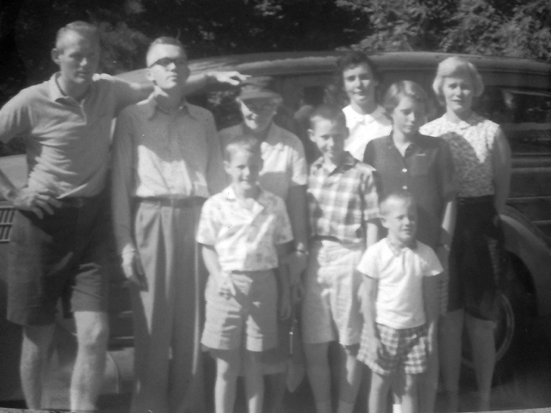My earliest memory is of taking a bath in the soapstone double sink that used to be in the kitchen at 29 Farm Pond Road. I was probably 2 years old. I grew up there every summer, staying with my brothers, my sister, my mother and our Gramma Coholan and surrounded by a colorful cast of characters - our neighbors.

Photo above - L to R - Mark Coholan, Bill Coholan, Peter Grandfield, Dodie Coholan, Mike Grandfield, Cathy Coholan, Dorsey Grandfield, Dorothy Grandfield, Mark Grandfield in front.

"The secret to life is enjoying the passage of time,” said James Taylor many years ago. As I've been working on my family's house this spring I've been surrounded by time echoing around the old walls. In this uncertain era, time has both taken on and lost meaning. The daily, present time has become, for me, somewhat surreal as the usual markers of days and weeks are like riding on a carousel. Then there's the constant parade of glimpses and flashes of the past in the house. While restoring and cleaning the property, I find myself on the same porch where I sat as a young boy pulling ticks out of the dog’s ears with various Peases and Stevens kids; where I sat for lunch with my grandmother, mother and sister; where we had parties overlooking the back yard and pond; where I got married. Working in the kitchen, I remember sorting through blueberries that Dorsey and I picked up by the Hyde’s house and waiting for the toast to shoot out of the old toaster. The living room is where I'd play Rummy with my grandmother and we'd have family dinners and toast marshmallows in the fireplace. All these images are strangely vivid as I work around the house - as though a slide show is displaying images on the walls. There's a mixed bag of feelings conjured up - some embraced and some pushed down before they can make their way to the surface. This vessel of personal and family history brings joy, sadness, nostalgic longing for an idealized past and an acceptance of the present that's just out of reach. Time, to me, is like a swirling cloud holding memories, and aspirations and although these things are always there, being in and around this old house has brought them to the fore. Eventually the imposed restrictions of the Pandemic will go away but this reflective time spent here in Harthaven will stay with me long after.

**Living with the Essentials**

**By Nan Bacon**

When friends ask if I’ve moved into my new house in Harthaven, I say “not officially but I’m living with the essentials.”

In early February of this year, final inspections were made and I was issued a Certificate of Occupancy. Shortly after that, on February 16th, Sam left for Hawaii. I felt some concern about his trip, and he did too. At that point, the virus was just making news. No one knew much about it or what was to come.

Once Sam had finally arrived safely in Hawaii and I had shipped all the contents from his “lost suitcase” (which had somehow disappeared off the Peter Pan bus and ended up in New York City) I figured I could finally concentrate on moving into my new house. But each day the news brought more concern and alarming stories about the coronavirus. Soon we were being asked to “stay at home.” All island businesses were told to close except for those considered essential, and construction crews and landscape crews were told they couldn’t work until further notice.

Now, I found myself hesitant to even drive over to my new house. I was concerned about the effort needed to move in and whether I had the energy to pack up. After nearly two years of building, I was exhausted with all the decisions and details I had worked on. I was excited to experience living in Harthaven, but the move felt daunting!

There was a small punch list still to complete and many things I needed to learn about the new house, but with workmen ordered to “stay at home” they couldn’t help me. Figuring out how to turn my oven on was a major feat. After weeks of trying and failing, the service people discovered that it was on “demo mode!” My WIFI and cell phone didn’t work so I had no way to call out or stay connected. In normal times that would not have been such an issue but with the pandemic I needed a means of connection in case of emergency.

When we were initially asked to stay at home, I figured I couldn’t hire any movers. And frankly, as much as I wanted to move, I worried about catching the virus - and I needed the comfort of my old home. I justified my need by telling myself I could use this “unprecedented” time to begin to sort and organize what I wanted to take to the new house.

As I began that task, I discovered piles of old clothes set aside for mending. For the next couple of weeks, I parked myself in my living room, enjoying the calm that came over me as I sat quietly sewing and reflecting. I had forgotten how much I enjoyed the simple pleasure of working with needle and thread. Hours flew by. Phone calls and texts to family and friends consumed my time too, as I was trying to make sense of how we were all now living. What were we were supposed to do - to avoid getting sick and to stay healthy?

By late March, I would travel to Harthaven every week to check on the house and start to clean. Slowly, I gained confidence about how everything worked. In April, since I was spending more time at the house, I decided to begin living there full time. I had no real furniture. In my living room, I had been using blue industrial moving pads for rugs and my outdoor furniture. Though I missed having a couch, I was fine. I was making do.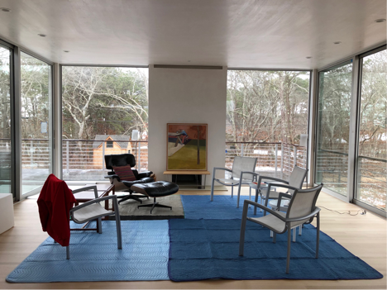

I stocked the bar and some of my cupboards with staples. Each week I brought a few more essentials - six plates, a few coffee mugs, a small French press, silverware, a skillet and a sauce pan. I created a temporary bed with two cot size bed frames and a mattress from my old house. I added a down comforter, a few pillows, two bedside tables, reading lamps and a few good books. I was all set.

I’ve always enjoyed making do, living simply and sparsely at our summer house. I thought, “why not do it here?” We’ll see how long that lasts. Eventually, I’ll decide what I want to live with, and what more is essential.

Most important - now that I am finally living here, in my own house, in Harthaven - I know that a sense of community is essential to my well-being. This is now my home. The comfort I take from waking “the loop” - waving, smiling, and talking with familiar and unfamiliar faces – brings me peace and joy. And that sharing is essential to keeping this community healthy and intact in the best and worst of times and I am grateful for that.

**I am Grateful**

**By Andrew Moore**

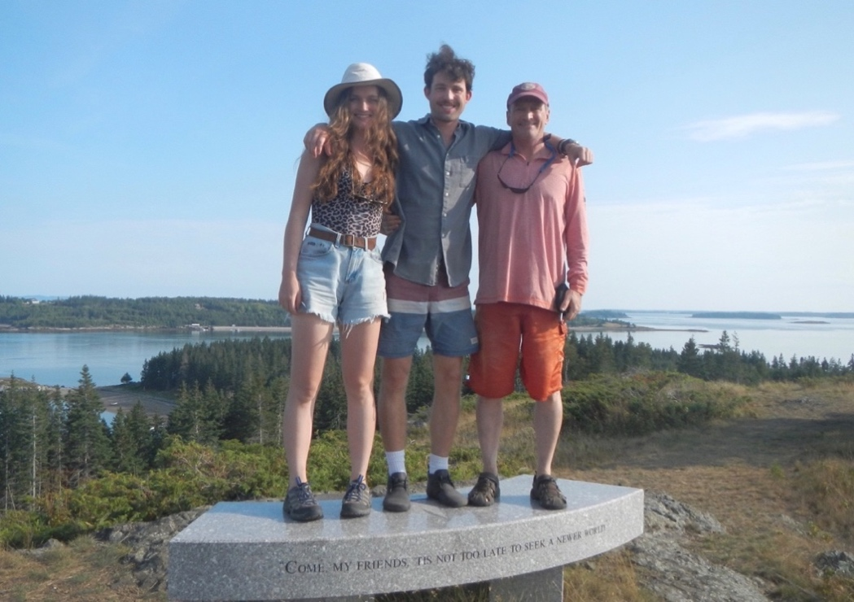I moved to Harthaven as a year-round resident in 1985 and I have seen many changes over the years. Harthaven is a microcosm of the world in general, at least the wealthier parts of it. Uninsulated summer homes have transformed into much larger multi-season homes and the population has grown exponentially. Landscaping, barely a thing in 1985, is one of the Islands biggest industries now. If we get through a day without the invasive thrum of a mower or leaf blower it’s a gift. Nothing, however, has brought on more change faster than Covid-19. This pandemic has stopped humanity’s constant business in its tracks. This disease is awful on those who cannot fight it and it is brutal on their families. I think it has also helped some families learn to live with less distraction and consumption and appreciate where they live and those they love.

My small group of Hannah, my daughter, Gordon, my son, and I have had a reasonable time these past Covid months. We are all self-employed and self-motivated artists of various types. We are fortunately free of the anxiety that people in very public jobs endure. Still, Hannah and Gordon, both in their twenties, miss a more robust social life. However, Hannah has channeled her Covid fears into making dozens of masks for family, friends and frontline workers and Gordon has focused on the demands of his last months of college. He graduated, online, last week!

For me, if you take away the masks and hand washing, off-season life on the Vineyard is much like it was in 1985. It is quiet in general, socially simpler, and nature is still out there, ready and waiting. I know gratitude is an overused term these days, but that is my strongest feeling. I live with my children and we are encompassed by family and a community I love, in a place I love.

I am grateful.

**Warmth and Rebirth**

**By Hannah Moore**

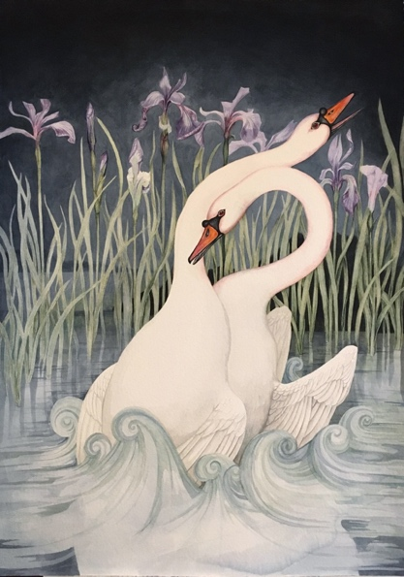My name is Hannah Moore, daughter of Andrew Moore and Heather Goff. I have lived in Harthaven most of my life. After graduating with a BFA in illustration I moved to Chicago and was there until last spring when I decided to move back to the Vineyard to focus fully on my artwork.

I have been lucky to live in places surrounded by wildlife, where I can go out and observe the ever-changing landscapes and the creatures that reside in them. A majority of my recent work is inspired by my observations of the natural world around me and also from trips to natural history museums. I started this painting of two swans when I was living at my grandparents’ house in Chilmark last summer. They live on a beautiful little farm with a pond that all the kids would swim in growing up. Wild irises appear in full force along the pond banks in late May. After the daffodils, they are the flower that comes to mind when I think of the beginning of warmer days. On the way to my grandparents’ house there was always a pair of swans that lived on Old Mill Pond near Alley's General Store. For years I'd see them out swimming. Looking back, I like to think it was always the same two. I wanted to combine these instances that remind me of warmth and rebirth with the coming summer.

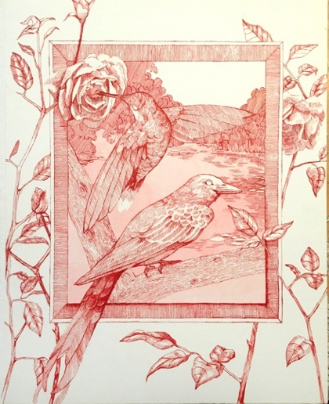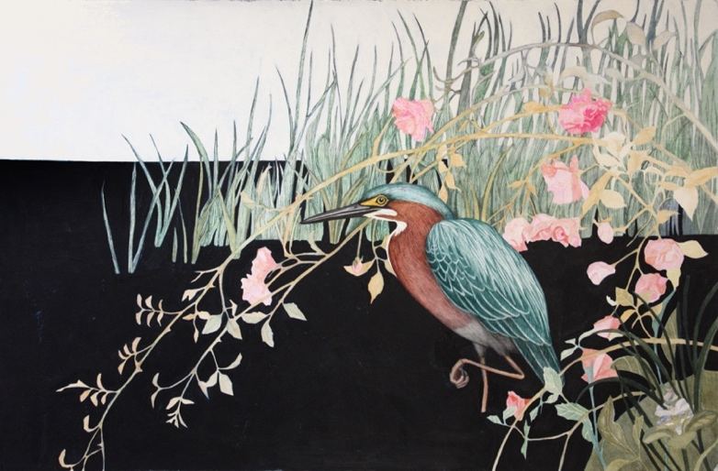I have been working mostly in watercolor and ink this year and focusing on nature-based scenes. I will be having a show at the Field Gallery towards the end of July. It is currently scheduled to open July 26th but due to the Coronavirus Pandemic it may be postponed a week or two and open in August.

**Comfort Within Constant Change**

**By Gordon Moore**

I remember graduating from MVRHS like it was yesterday, and setting out into the unknown, overwhelming world of college. By some miracle, I was accepted into the Brown/RISD dual degree program. Through this 5-year program, I was able to take academic classes at Brown and studio courses at RISD, fulfilling two four-year degrees in 5 years. Growing up in a family of artists, I was determined to be the outlier—the one who would finally make money—so I entered Brown and RISD planning to study engineering and industrial design. The past five years have been some of the most challenging, inspiring and rewarding years of my life.

Last weekend, I graduated from the Brown/RISD dual degree program with a BFA from RISD in Film/Animation/Video and a BA from Brown in the history of art and architecture. Not quite the money-making combination I set out to acquire, but an intellectually-captivating one nonetheless.

I had eventually chosen animation as a major at RISD almost to avoid choosing a major; animation allowed me to make work in any medium I wanted, and film assignments showed equal flexibility; they could be narrative, music-driven, commercial, experimental, viewed on screen, viewed in an installation, whatever I wanted! Ultimately, studying animation made me think deeply about how we consume art online, and how artists translate their ideas into something which can be viewed through a screen. During my art history classes at Brown I always had a similar interest, as all of the works we studied—whether paintings, photographs, sculptures, archeological artifacts, or buildings—were viewed in the form of a photograph in a textbook or webpage, accompanied by written description. There always existed a sort of physical translation. I will return to this idea shortly.

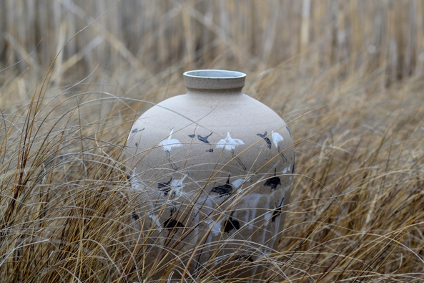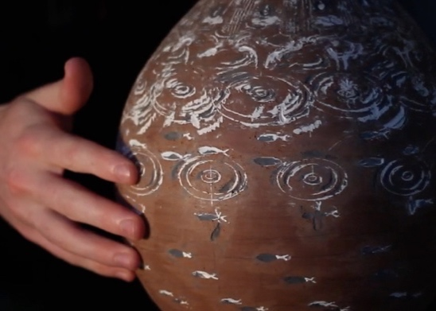

Alongside my studies in art history and animation, I have had an affinity for object-making, generally using ceramics as a medium. I love to make functional pottery which becomes integrated into my routine or the routines of friends and family. Devoting so much time to making and using functional objects, like mugs and teapots, I acquired a new perspective on objects, ultimately understanding that the way we think about an object changes over time. Objects obtain personalities, much like a person does and, in turn, familiarity heightens aesthetic beauty. Sometimes the most subtle, humble pieces of pottery feel the most alive after a year of use, whereas the pieces which were striking at first may lose their appeal, much like an over-saturated photograph which catches your eye but quickly becomes tough to look at. We experience objects over a duration of time. It is comparable to light which exposes film. A bright light will perfectly expose a photograph with a fast shutter speed. But given a long enough exposure, a dimmer light will illuminate a photograph more subtly and with greater richness. A simple pot, when lived with and experienced day after day, will shine.

So, this brings me back to the idea that most objects are viewed only as a single photograph online. That single image is as inadequate in portraying an object as a single picture is in conveying the totality of a person. The disparity between the ways an object is experienced online versus first-hand presents a dilemma for the object-maker who is conscious of the digital consumption in his work’s future. It was this topic of the two lives of objects—one which is experienced in-person day to day, and one which lives online—that led me to my thesis film for RISD. What can one show that the other cannot? For my film, I designed ceramics specifically to live online. These pots operated the way a zoetrope does, with sequential frames of animation inlaid into the circumference of each pot, brought to life when the pot is rapidly rotated on the potter’s wheel in front of a video camera. At just the right speed, the frames of animation on the pot’s surface would line up with the shutter speed of the camera and seem to freeze the spinning pot and breathe life into the animations on its surface.

Due to the pandemic, I returned home to the vineyard during my last few months of production on this film, which I had been working on since October. As a result, my film became very much about my home on the Vineyard and the different landscapes which have inspired my work. The pottery made in the film is inseparable from myself and my life observing nature on the Vineyard. This is an island of constant change, where the coastline morphs in erosion and deposition, storms and calm alternate, and people and wildlife come and go with the changing seasons. I wanted the pots in my film to undergo similar change as they spin into and out of sync on screen. Living on the Vineyard has taught me to find comfort within this constant change around me, for even the coldest winters return to warm summer days. The heaviest storms eventually dissolve into gentle rain. My film is called “Rain Pot” and will be traveling virtually to festivals this coming year as I start my art-making career here on the Vineyard.

**You can see Gordon’s film here:** https://vimeo.com/417641972/7fb7dec606

**How I Spent my COVID Spring**

**By Alfred Woollacott**

Tuesday, March 10, Tefts, Austria – I had come as part of this year’s biannual trip to compete in a hockey tournament. We, the Cape Cod Sharks, were fatigued but heartened as we relaxed in the locker room after a vigorous skate. The scrimmage games had gone well, an encouraging sign for the upcoming tournament. We headed to 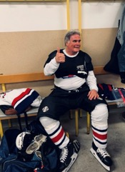a local tavern to meet our Austrian opponents, now comrades, for food, drink, and fun. The camaraderie that followed reinforced why I take these trips. Then a sobering thought came, “I am seventy-three years old. Will I have enough in the tank for 2022?”

Wednesday, March 11 - we visited the Innsbruck Olympic Ski Jumping Center. Standing on the 250 meters high platform and looking down the steep run, the landing area seemed like a distant postage stamp. Just past the landing area was a large cemetery. What a diabolical sight it must be for jumpers as they fly toward their landing spot, perhaps while praying they don’t overshoot.

We left Innsbruck, motored through the Austrian Alps, and arrived at Füssen, Germany. Our hotel prepared a pre-tournament banquet for us, rekindling more camaraderie. In bed that night, I thought about the cavernous Füssen rink compared to the local arenas where we skate, suggesting a big-time tournament. My thoughts drifted to the Neuschwanstein Castle and Dachau side trips and a return to Iceland next week for more hockey and the northern lights. Jill had missed this trip due to unforeseen complications, and I missed her already. Like my teammates, I had vacillated about going. But Jill encouraged me, and I didn’t want to let the team down. “Everything will be fine” was my final thought before nodding off.

Thursday, March 12 - 3:00 a.m. The phone rang. German-accented guttural commands – “Pack your bags. Your bus is leaving soon.” Pandemonium greeted me in the lobby. President Trump was closing our borders - we had to get home. My son Justin lives in Colorado and was still awake. He texted me offering help. He works for EF Educational Tours, so he is more adept booking flights quickly than me, who was frantically navigating websites, some in German, on an I-Phone, amid the chaos. Justin locked onto an 8:00 a.m. Munich flight at a reasonable price. But a delay ensued while the site’s algorithms worked their sorcery before he could book it. The cost had more than doubled. Bandits! Getting to Munich in time was tight, but we made it. I checked my hockey bag and three sticks taped together. The attendant said, “Two bags at hundred Euros each. Shall I charge your credit card?”

“A hundred Euros for three hockey sticks?” She didn’t respond. “More bandits,” I muttered.

We neared Logan in the early afternoon Boston time, and perhaps due to fatigue, my overactive mind went into hyperdrive. I felt feverish and foresaw a rigorous, health screening process for my re-entry. “Would I be quarantined at Deer Island for 21 days?” Logan was eerily quiet as I bustled along the corridor toward customs. My anxiety increased when the Custom’s Officer beckoned me. I told him where I had been. He asked whether I had been to Italy. I said ‘no.’ Still stone-faced, he leafed my passport and asked about China. “That was last October,” I said. He waved me along. My daughter Vanessa was waiting outside the terminal. I made the 5:00 pm boat home – fortunate, indeed, and living proof that God takes care of fools.

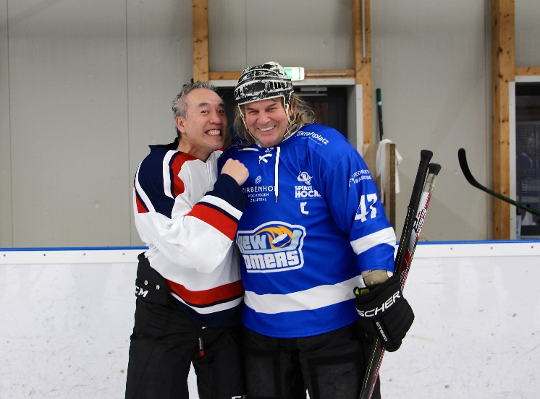

Everyone else made it home safely, too. Sadly, my linemate, Victor Ng, caught COVID six weeks later. (He is shown with the ‘Austrian beast’ after the game) He spent time in the ICU, on a ventilator, and is now recuperating at Spaulding Rehab. His ninety-year-old mother died from COVID while he was in a coma. The hockey brethren and others sent numerous Facebook and WhatsApp prayers. I believe they helped him through it.

We self-quarantined for 14 days, and then the Governor made it mandatory. My weekly routine of tennis, skating, and occasional weights (to fool myself I’m toning an aged body) had vanished. Walks with Jill were my only exercise. But walking - as opposed to concentrating on a ball or puck and thinking about the next shot - doesn’t distract you. So, I felt the aches and pains more on those simple walks.

Cooped up, I turned to the cerebral - my avocation - family history and genealogy. With some help from another genealogist, I traced Jill’s Mayflower line back to her tens-greats grandfather Stephen Hopkins. Hopkins was an interesting chap. He left England in 1607 for Jamestown, became shipwrecked off Bermuda, eventually found his way to Virginia, and returned home circa 1614. While away, his wife had died. He remarried and again set out for the New World with his new family on the Mayflower. While at sea, his son was born and aptly named Oceanus. Early on, he worked with Myles Standish and Edward Winslow to establish the new colony. He built an “ordinary” (a tavern) on the outskirts of Plymouth. Court records later cite him several times for the ‘crime’ of serving on the Sabbath, playing games and other such misdemeanors, and selling spirits at excessive rates. He fell into disfavor. Jill has no interest in being a Mayflower Dame, but should any of our direct descendants ever wish to join the lineage society, the documentation exists.

I decided to finally get on with a long-contemplated, fourth article for the Massachusetts Society of Genealogists writing contest. These articles need to be heavily researched and rigorously formatted – mine was twelve pages, 150 footnotes. My article focuses on Jill and Sam Low being thrice-related (a rarity in genealogical circles). William H. Hart (the first resident of ‘Harthaven’s White House’) is Jill’s two-greats grandfather and Sam’s great grandfather – so in the Hart line, they are second cousins, once removed. Valentine Burt Chamberlain is their shared great grandfather – so in their shared Chamberlain line they are second cousins. Tracing those relationships was easy, unlike the third. Jill’s father is Sanford Ballard Chandler Jr. When I learned that Sam’s father is Sanford Ballard Dole Low, my genealogical antennae shot up. I am familiar with the naming patterns of those of us of English descent. I am Alfred III, for example, showing that we have lacked imagination when naming firstborn sons. So, two uncommon names linked together had to be more than coincidence. After considerable research, I found Jill’s and Sam’s common Ballard ancestor. Jonathan Ballard, born at Billerica in 1723, is Jill’s five-greats and Sam’s four-greats grandfather, respectively. So, following the Ballard line they are also fifth cousins, once removed. Thrice related. That’s pretty rare.

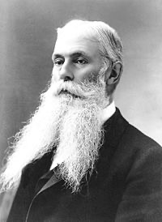But what about those two uncommon names linked together – “Sanford Ballard?” Sanford Kingsbery Ballard was born at Hallowell, Maine in 1815 and attended Bowdoin College. He practiced law in Gardiner, Maine, and died in 1841. Several Ballards named their sons Sanford most likely to honor this aspiring lawyer whose promising career ended too soon. Emily Ballard, Sanford’s older sister, married Daniel Dole in 1840. As Christian Missionaries, she and Daniel arrived at Hawai’i in 1841. She gave birth to her second son in 1844 and named him Sanford Ballard, after her brother. She died four days later. Sanford Ballard Dole (photo at right) was raised and educated by his father. He attended Williams College in the 1860s and was married at Castine, Maine in 1873 before returning to the Hawai’i. He was elected to the Hawaiian legislature in 1884 and 1886, became President of the Republic of Hawaii for a six-year term in 1894, and inaugurated as the first Governor of the Territory of Hawaii in 1900. He is Sam’s great grandfather. Jill descends from Jonathan Ballard via a different lineage and other Sanford Ballards.

Ancestors from the Hallowell area, New Britain, Connecticut, and the Hawaiian Islands have two twenty-first-century descendants living in Harthaven on an island eight miles and forty-five minutes from ‘America’ who are thrice related. Perhaps only a family historian and genealogist can appreciate that morsel of trivia, but for me it was intriguing detective work – a perfect cerebral journey during this time of sequestration.

**Contemplating Beauty**

**By Sissy Biggers**

“Those who contemplate the beauty of the earth find reserves of strength that will endure as long as life lasts.” *Rachel Carson, Silent Spring, 1962*

On that now fateful Friday, March 13, 2020, my husband Kelsey and I rolled onto the Woods Hole ferry eager to check on the spring building progress at 229 Seaview in Harthaven. Instead of a short sojourn so began 60 days of isolation.

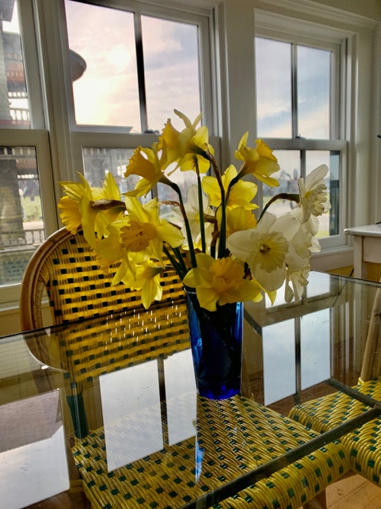We sheltered in place at our home on Ocean Park where, in 22 years we could count few March visits. The expected off-season quiet turned to desolation as the churning of the MVTA buses fell away and the constant flow of cars on Beach Road slowed to an irregular swish. The construction hammering stopped, the landscape blowers were muted and a trip to Reliable became a hushed rush of wide-eyed masked shoppers.

As the prospect of this unexpected, unknown, silent spring dawned, I searched for strength in my daily Oak Bluffs walk.

A self-described “frantic peripatetic” -- having fast-walked the New York City Half-Marathon only last St. Patrick’s Day -- I was determined to brave the shuddering, wet winds of March. I scrounged a pair of hiking boots and a knit cap from a forgotten trunk and shook out my South Beach layers. With the bonus pocket find of a now coveted squeeze hand sanitizer and a crumpled bandana, so began my daily routine.

When I can’t sleep, I imagine an aimless, Oak Bluffs walk--tracing the familiar routes eases my mind into drowsiness. On those first days I set out, directionless, with a similar sense of near somnolence--until the fierce winds set my course. Day after day, a northerly blow pushed me through the empty streets behind Ocean Park, to the Circuit Avenue side of Farm Pond in search of inland cover. Tiny, song-less seabirds bobbed in the reeds in the current as I beat along the boards of the raised walkway. I traced the oft trodden course of the “midnight bike ride” (the pine paths our kids pedaled on moonlit, summer nights) winding through the winter scorched lanes to the eerie emptiness of the Oak Bluffs School where school lunches were handed into car windows, offered a slight sense of other days. Circling Trade Winds without the canine community offered little distraction. The back entrance to Harthaven was an obstacle course of winter trenches along Martha’s Park. Staying surefooted along the slippery horseshoe stretch of Harthaven Road was rewarded by a glimpse of the stilled construction at our Seaview home. The bike path return to Ocean Park was a ceaseless blow of sand and spitting white capped spray and the diagonal walk across the Waban Park was the final test until the shingled eaves of Tuckernuck Avenue provided a slight shield until home.

It was a daily, solitary march -- every step challenged by the elements and my fruitless imaginings of the unknown of the spring of 2020. And then, I heard the song of the Pinkletinks. Mother Nature finally turned the page offering her full reserves.

The tiny marsh frogs took the stage with their cacophonous chorus. My gait hastened to Farm Pond, moving with the deafening shrill, which grew louder as the days grew longer.

The muddy edges of my wooded ways sprung guideposts of the yellow and orange trumpets of daffodils. The mounded hill at the edge of Harthaven was a riot of soft, curled cups standing stiffly against the wind.

Onion grasses spiked the edges and scented my daily route - beckoning eager foragers.

The piercing blue sky lightened my dark musings as new company in the whistle and gurgles of the nightingale floated over the Ocean Park towers. The hungry call of the osprey neighbors wafted above the beach road.

The downbeat of the hammer soon kept time with the welcome whine of the bandsaw.

Smiling eyes offered muffled, masked greetings at Reliable.

I had endured.

**The Pandemic and the Aumakua**

**By Sam Low**

When the Covid-19 virus spread across the United States, I was in Hawaii doing research on a book about Hawaiian cowboys, particularly my grandfather who was one of the most famous of riders and ropers on the broad plains of the Big Island. The pandemic entered my consciousness rather slowly, beguiled as I was by the homeland of many ancestors. I had intended to fly back to the Vineyard on Monday, March 16th after attending a reunion of my Hawaiian family on Saturday, March 14th, but as I learned about the seriousness of the virus and its rapid spread I thought I might be marooned in Hawaii. As the death toll mounted, I became more and more anxious. If I was going to draw my last breath where would I want to be? The decision was clear. It would be Harthaven.

I managed to change my reservation on to leave Saturday and I was all set to forget the family party - this chance to meet so many of my Hawaiian relatives. On the way to the airport, however, my *aumakua* intervened. The *aumakua*, Hawaiians believe, are ancestral spirits who guide us on our path. I heard the voice of my grandfather - “I understand your fear and your anxiety, but this is a chance to tend to your Hawaiian roots. Please don't fly home today. Go to the family reunion and fly on Monday.” I took his advice and changed my flight at the airport.

The reunion was wonderful. The flight home was uneventful. I sequestered myself in my Harthaven home for 2 weeks, but I was not exactly alone. The voices I heard were now from both families, Hawaiian and Yankee – spirits from my two homes. “Well done,” they said. “You have two homes. You have chosen the one of most comfort at this difficult time. But you have also honored the Hawaiian side of your family.”

**Young Harthaven Artists**

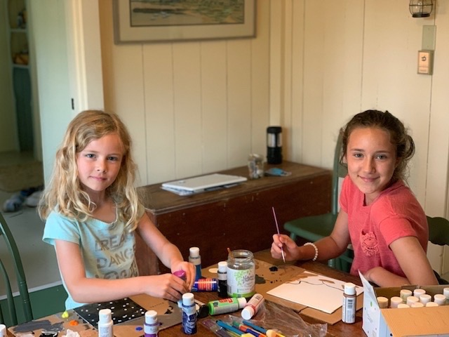

**Sofia and Cassie Hellstrom** - Sofia Hellstrom, left, age 11, and her sister Cassie, right, age 6, live in the Campground House at 30 Martha’s Park Road. They are delighted that their parents Jed and Linda can work remotely and have decided to spend the entire summer in Harthaven. They look forward to fishing, swimming, clamming and cooking smores in the backyard fire pit beside their tent camp. When your editor invited each of them to contribute a painting to the Herald – something on the theme of what they loved about the Vineyard, they accepted with alacrity. Here are the results

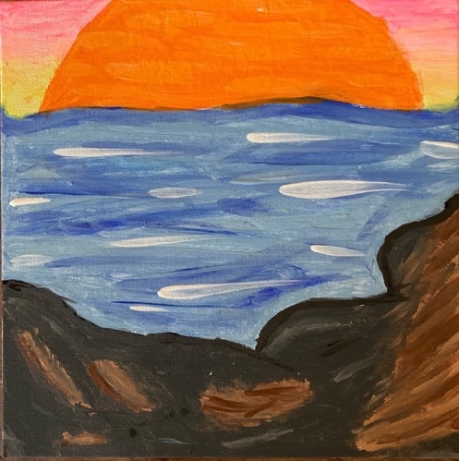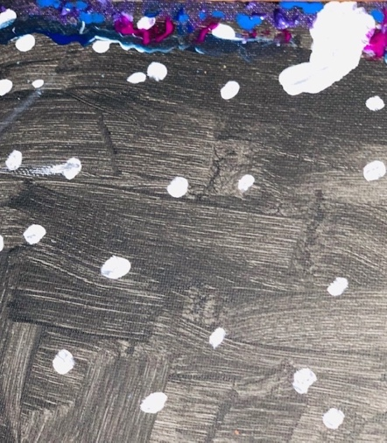

Left: Cassie: “I love to look up at the stars from our backyard at night.”

Right: Sofia: “I love the beach. This is the view from my favorite rock at the end of the jetties – a little nook where I like to sit.”

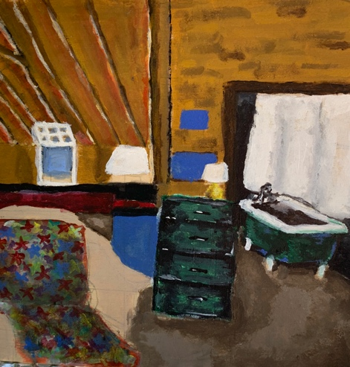

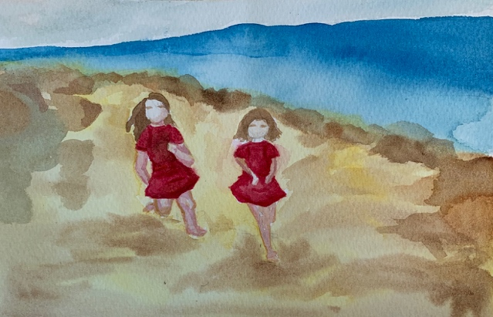

**Chloe Baxter** - The Hellstrom artists love to spend time with their best of friends, Chloe Baxter, who is also an artist. Here are two examples of Chloe’s latest works - one in Acrylic, the other in water color.

**New Permanent Resident Penny Pease!**

**By Peter Pease**

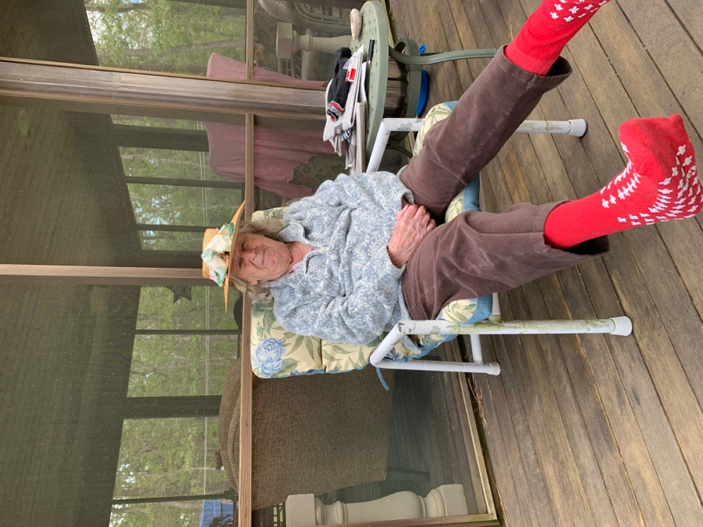It may have taken a lifetime, but she has finally made it home at age 96. Penny has been living at the Carleton Willard village in Bedford, Massachusetts, since 2003. On May 31, her daughter Polly brought her down to live with her son Doug and his husband Richie at 22 Farm Pond Road. She has visited Martha’s Vineyard nearly every year of her life and will now become a true islander.

She was born and raised in New Britain, Connecticut, along with so many other Harthaven families. Her parents, Herbert Hoyt Pease and Mary Curtiss Pease, first came to Oak Bluffs in the 1930’s. Penny and her children have enjoyed a few weeks here every summer of their lives. When you really love a place, why go somewhere else? Like so many others, our roots here run very deep.

Penny is delighted to be here, with her family and their friendly dogs. It has been a difficult time for all of us, in this season of pandemic. It has been particularly isolating for our elders. She is very happy to have escaped the months of quarantine. We cannot recommend Carleton Willard more highly, as their staff are excellent and loving in their care, but there’s no place like home.

Our Pease family is delighted to welcome Penny. As you can see from this photograph, she has arrived complete with her playful attitude, and looks forward to seeing everyone. Her many grandchildren cherish their grandmother and celebrate her spirit with a special nickname. They refer to her as “the Graminator.” Stay on her good side!

**Welcoming Penny**

**By Doug Pease**

We prepared for Penny’s arrival by doing all the usual things that one would expect - but my husband Richie adores and knows her as much as her children and decided that he would welcome her in personal ways that she would especially appreciate. When she was younger and visited us in the summer, Penny would often go out at night to gaze at the moon rising above the trees, so Richie reoriented her bed so she could see the moon though her window as she drifted off to sleep. Mom also loves birds - they are an essential part of a great day. A few weeks before Penny's scheduled arrival, Richie went down to his basement workshop. With scraps of wood he fashioned bird houses - five of them. He made one painted red, white and blue like an American flag. He made one with a bright yellow front door. He made a log cabin birdhouse. He sculpted the entrance to another and painted it to look like a pea bod. And he positioned them in trees all around the house, so she could see them from every window.

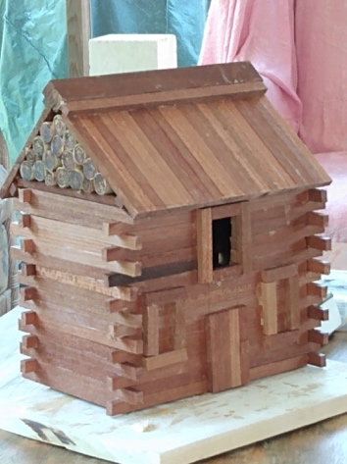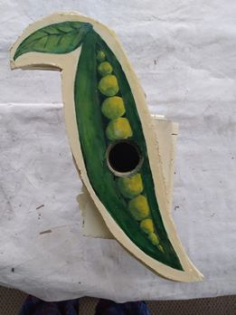

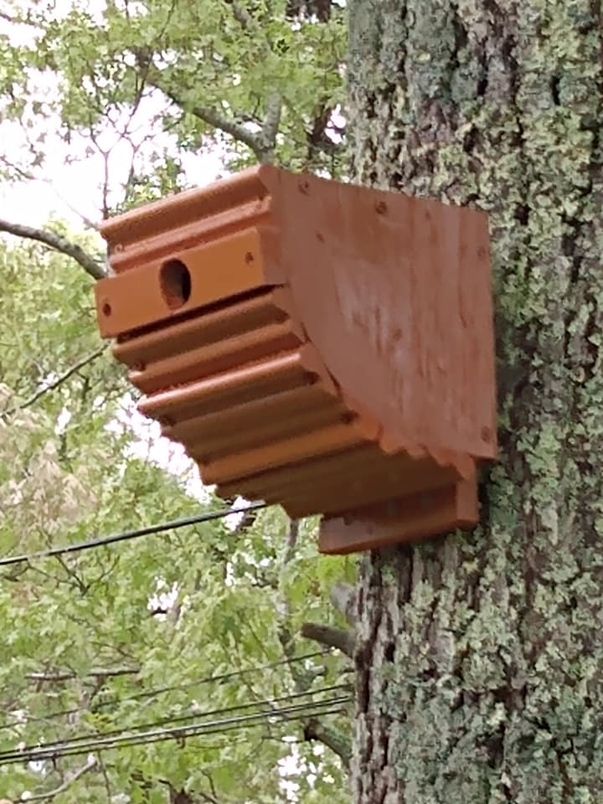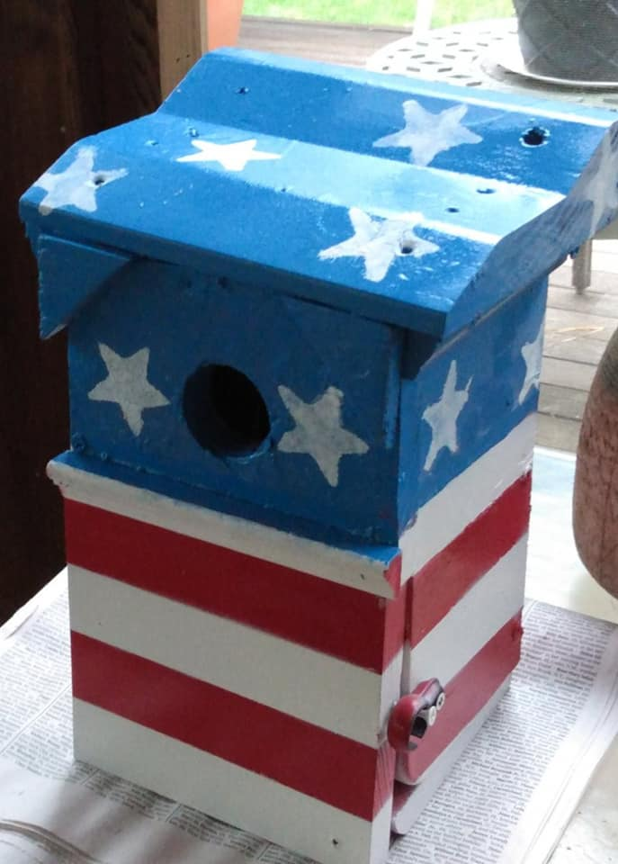

**Dr. Thomas’ 93rd Birthday**

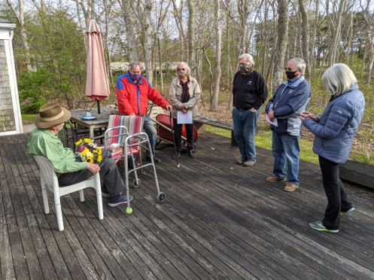*On Monday, May 18th, a group of Harthaven friends social-distanced at the home of Dr. John (Jack) Thomas to celebrate his 93rd birthday and his 51st anniversary as a Harthaven landowner.*

“I first came to Martha's Vineyard in the summer of 1969, the year that Ted Kennedy proved himself to be such a good swimmer,” Jack wrote some time ago for our website. “That was the year in which traffic jams caused by morbid curiosity seekers trying to see the infamous Dike Bridge, stretched all the way back through Edgartown, sometimes as far as the triangle. It was also the year, if I remember correctly, that men first landed on the moon. Which was the most significant event? Certainly not my coming to the Vineyard. One of the other events may have changed the course of American presidential history; the other, who knows?

I came to the Vineyard at the urging of Allan McDowell, the father of Ba Dutton and Lanny McDowell. Allan had been a patient of Benjamin White, the senior partner in our medical partnership. When Ben retired, Allan, even though he lived way out in Kent, Connecticut, continued to come to Hartford to see me for medical advice. In the spring of 1969 it came out in conversation that my family and I were planning a summer vacation on Cape Cod. Allan expostulated ‘Oh no, Jack, come to the Vineyard instead!’

Fortunately, I was able to extricate myself from the Cape Cod arrangements, and we rented the main house at Crow's Nest for three weeks that year, and the Mess House for the next two years. Russ and Barbara Hart were our landlords.

Allan was a tireless advocate for Harthaven and eventually convinced me to buy the lot back here in the woods where my house now is. I have been coming here ever since.”

**Hello Harthaven Neighbors**

**By April Miller Boise**

We want to introduce you to our family. We recently purchased the home at 6 Martha’s Park Road. We have been visiting the Vineyard for more than 20 years for vacation and are so pleased to now have our own home on the vineyard so close to the ocean and in such a wonderful neighborhood. We have already met many of you — especially while riding the Peloton bike in our garage — and look forward to getting to know you more. We are David Willbrand and April Miller Boise and four kids who are now young adults. When we are not on the Vineyard we are mostly in Cleveland, Cincinnati and Chicago. Both David and I are attorneys and can be found working remotely from the Vineyard. Our children are Ella - graduated in May with honors with a degree in anthropology from Hawaii Pacific University (she is still hanging out in Honolulu); Ethan - a rising senior at Cal Berkeley; Maxwell - a rising senior at Syracuse; and Zoë - a recent graduate of Cranbrook Kingswood academy who will attend Syracuse in the fall. Our girls are pretty disappointed, like many graduates, about missing several major milestone celebrations this year. But we are all doing our best during quarantine and happy to be on the island for it.

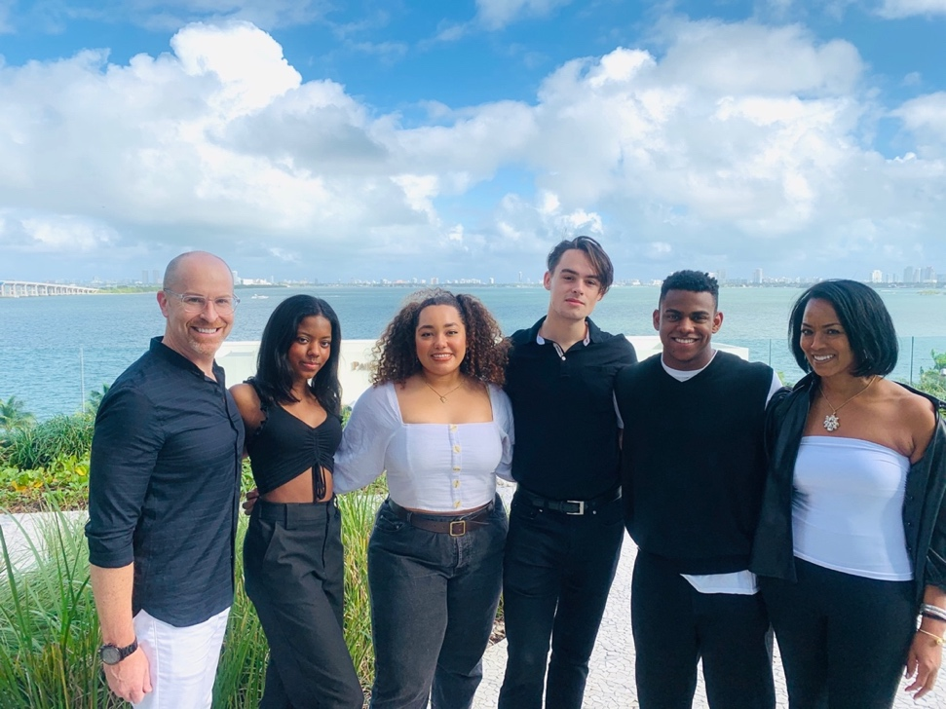Left to right **-** David, Zoё, Ella, Ethan, Maxwell, April

**Community Currents**

***Quick newsbytes from around the hood***

On April 23rd, as the pandemic spread across the country, Ron Moore and Janice Ralston found themselves marooned in Florida.  With their car packed full of food, they headed north - driving 1600 miles to get to Martha's Vineyard two days later - the last car allowed aboard the 10:45 ferry. Now, finally back in their Harthaven nest, they enjoy daily walks in our neighborhood or downtown Oak Bluffs.

On May 15th, Chris Birch and his daughter Heidi, who just completed her sophomore year at Skidmore College, opened their home on Farm Pond and spent three weeks painting and getting it ready for rent. Chris will be back in October to enjoy a few weeks of peaceful fall days.

Eric Hager (who lives next door to the Birches) reports that his daughter Elizabeth Finley, her husband Chris and daughter Jane opened their home at 51 Farm Pond Road on Saturday, June 6th, and will be in residence for a month. Eric is looking forward to escaping the chaos in Washington, D.C. toward the end of June to take up residence for an “open ended stay.” An interesting footnote: that end of Farm Pond Road has become Harthaven’s showcase for modern and contemporary architecture. The Birch and Hager/Finley residences were designed in what I would call the “midcentury modern style” by former Harthaven residents (they have passed away, unfortunately) Allan McDowell and Max Moore. And these homes are now joined by Nan Bacon’s “contemporary style” home designed by Patrick Cosgrove. (Full disclosure – I live in one of Max Moore’s homes and love the simple open architecture and large windows facing Farm Pond).

This is the first time that Randi and Adam Markel have been able to get here in June. “We bought this house 15 years ago,” Randi reports, ”and we've never before seen the Rhododendrons all in bloom. It is so beautiful!” In July, the Markels will be joined by their four children - Chelsea and her husband Matthew Stein (they were married in October last year); Lindsay with her fiancé Connor McMorrow; Max, who will be a senior at the University of California in Santa Cruz and is studying environmental economics; and daughter Eden who just finished her first year as a political science major at U.C. San Diego.

Alison and Matt Carothers made the best of the lockdown by running their setters in the woods every day and catching up on a long list of movies. Their boys Standish and Crossan finished up their high school year from home, and though they missed playing lacrosse and seeing their friends, have made the best of it. Alison's father, John Barry, will be arriving on the Vineyard soon along with her sister, Lisa Barry, and her kids Jenna and Garret, and they are looking forward to having all three generations together again.

Chip and Molly Linehan arrived on island in late May and plan to spend the whole summer here. They are joined by their children Cormac (age 10) and Maya (age 9). You will likely see the kids paddle boarding around the harbor, fishing off the jetty or walking their dog, Mango, on the beach.  Please say hi!

Lou and Ginger Sullivan continue to shelter in place in Atlanta and will return to Martha’s Vineyard as soon as it is safe to travel. “Very proud to announce, Grandson Paul Jr. graduated from St Marks School of Dallas, and will attend Northwestern University in Chicago,” Ginger writes. “Our daughter Shanta returned from a Dartmouth Alumni two-week tour of Egypt just before the shutdown. Son Halsted is the Executive Producer and showrunner for the animated musical show “Central Park” on the new streaming service Apple TV+ which is currently airing.  The show received great reviews, including the New York Times.” Halsted has written or produced many programs on television and has been nominated for (among other awards) three Emmys, two of them for his work as producer for the “Outstanding Comedy Series” award on the hit TV show “The Office” in 2011 and 2010 and in 2001 for “Outstanding Writing For A Variety, Music or Comedy Program” (The Chris Rock Show) in 2000. I hope we will have a biography of Halsted in the next edition. You can read the New York Times review here: <https://www.nytimes.com/2020/05/28/arts/television/central-park-review.html>

Arthur Stafford and Diane Burwen plan to become Mr. & Mrs. Arthur Stafford sometime in the next few weeks. Covid has forced them to delay a planned celebratory gathering to “sometime later.” Arthur’s Daughter Shelley, her partner Ron and Arthur’s grandchildren Josh, Sean and Leyna will be here in early August rather than the usual fireworks week.

Wesley Brown writes: “The last few months have certainly been a different time.  Daily life consists of leaving home as little as possible trying to stay safe and well. Necessities bring me out with mask and sometimes gloves.  I am playing the piano, working on a 1000-piece jigsaw puzzle, spending lots of time in the garden, playing the organ at Trinity Church by myself since we will not open this season, attending to my treasurer duties at Trinity and St. Andrew's, watching Netflix and Amazon, enjoying Shelley's wonderful cooking, attending to the business of Hart Realty, and spending way too much time on the computer!  And finally, I am grateful for my family and friends, and the advantages that I enjoy being retired over those who still must work and risk their health and safety during these uncertain times.”

Rebecca Everett reports: “Jennifer has launched and rigged her Bauer 12 sailboat. She and Michaela are eager to enjoy the water. I finished prepping “Saba,” my 1967 O'Day Mariner formerly owned by Ed Abbe, and will launch her soon. Trina and her family are looking forward to their annual August vacation in Harthaven from their busy garden center in Connecticut. Dick and Mary will be here intermittently throughout the season.

Phronsie Conlin, now anticipating her 101st birthday, has sealed herself off from outside physical contact with the help of her care-giver. Her son Jed and wife Carol deliver food and mail and occasional visitors stand outside the sliding glass door to Phronsie’s porch to converse by cell phone. She and her care-giver travel the island byways by car from time to time and recently enjoyed a visit to Menemsha and Aquinnah.

“Ba (Dutton) is adjusting to life without her husband of many years,” her son Allan writes. “She is enjoying the simple things; warm sunny weather (Yay!), the lush greenery and being with the family, including her 2-year old grandson. She misses socializing with family and friends (like Phronsie) that has been made difficult because of Covid. But she carries on!”

Mickey Graham has arrived from his home in Stamford, Connecticut to take up residence for the summer. "My deck is open," he says, "and I look forward to seeing all my Harthaven friends. Please drop by."

Elliot and Shirley Hall arrived from New York on Sunday, May 31, and were joined for a short visit the following Tuesday, June 2, by their Daughter Tiffany, son in law John Rhea and their 4-month-old grandson Theodore. “Theodore loved the beach,” Shirley reports, “and I am happy to be in Harthaven and on my front porch for the rest of the summer.”

Al and Jill Woollacott are proud of their granddaughter, Rya, for making the Dean’s List at the University of Maine for the second year in a row. “She has the brains and the drive of her grandfather,” Jill reports, “a combination to be grateful for.” Rya is entering her senior year in the fall, hopefully in the classrooms, and will have all her credits and degree earned by December.

“We arrived on May 15th,” writes Jessica Baxter, “and will be here the entire summer. The girls are finishing up school remotely. Next fall, Chloe will be entering 11th grade and Vivian will be in 8th grade. Chloe will be participating in a Sotheby’s Art Education summer camp remotely. Sadly, she’ll not get the New York City dorm experience, but she’s excited all the same. Vivian is looking forward to spending time with her Harthaven friends (Sofia & Cassie Hellstrom) and her best friend from the school year, Gabi, who will be on island much of the summer.  We’ll continue bike rides, beach time, socially distanced drinks and I will finally be taking tennis lessons.  Every time I drive out of Harthaven and see our harbor and the ocean beyond, I smile. Being here is our favorite part of every year but this summer we’re especially grateful for our Harthaven friends and community.

Rita Jeffers reports that Mia is looking forward to her senior year at Martha’s Vineyard Regional Highschool, Mason just graduated from Stonehill College and will soon be taking up a new job in Boston and the entire family are spending time welcoming their new puppy, Rosco, a thirteen-week-old Shihczu.

It seems like all the Harthaven kids are graduating this year! Nina Moore Howell reports that Jake just graduated from Tabor Academy and will be heading to Penn State in the fall if schools reopen; Courtney just graduated from Lafayette and is hoping to move to DC in the fall; and Kate will be a senior with Mia Jeffers at Martha’s Vineyard High school. Husband Bill has been very busy at Martha’s Vineyard Bank managing Paycheck Protection Program loans and Nina is back designing kitchens at Vineyard Design Center now that the construction ban has been lifted. Their dog Scout is busy chasing squirrels in the yard.

Dawn Warsofsky and Mark are celebrating the birth of their sixth grandchild, Harleigh Thomas Warsofsky, daughter of their number two son Jarod and his wife Katie. Number three son Ryan and his wife Caroline will come to visit in July with their ten-month-old son Cal. Continuing the parade of grandchildren, their youngest son David and his wife Annie, are expecting a baby on September 8th (can they be that accurate these days?) and will also visit in July. Dawn and Mark will be in residence most of that month and then back and forth from their house in North Marshfield where Dawn is overseeing a spate of renovations.

“We added onto our guest house last year in order to move our office from Vineyard Haven to Harthaven,” Stephanie Mashek writes. “Our timing was great given the need this spring for all of us to be working from home. We are loving being in the neighborhood more now. We look forward to a few grandchildren joining us this summer – after we all test negative – and to the change of pace. And we look forward to the birth of a ninth grandchild later in the summer.”

Martha Shaw reports that on December 8, 2019, her daughter, Sara Valentina Shaw married Sargent Ethan Brecto in San Diego.

Peter Yoars writes: “My daughter, Liz arrives in Harthaven this Thursday (June 18th) for a week including Father’s Day. Haven’t seen her since Christmas. Yippee!”

And this, just in at press time from Laura Bamford Thomas: “We Bamfords have been at ground zero (Oakland, California) with this scary virus and have been isolating for three months.  Haven’t even seen each other except for zooms.  We hope to visit the island this summer but no concrete plans yet.  When we arrive, we’d love to play pickleball and swim with whomever is willing and able!”

**Avian Residents Also Return to Their nests**

**By Sam Low**

*And the great cycle of nature continues. Our ospreys flew thousands of miles to their Harthaven home.*

Many years ago, the William H Hart Realty Company granted a portion of our beach as a conservation trust to the Vineyard Conservation Society. Felix Neck observes nesting behavior on the beach and makes annual reports. Here is the latest information for the year 2019 from their website.

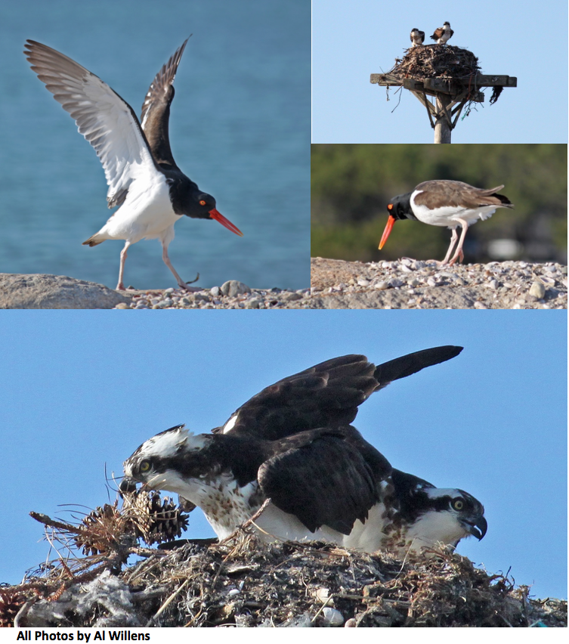“Felix Neck staff monitored Harthaven for piping plover, tern, and American oystercatchers’ presence from March 28, 2019 to August 26, 2019 on 48 site visits. Monitors erected and maintained protective fencing at the site and provided informal education to interested residents and beachgoers. Least terns were observed feeding at the site periodically throughout the season. One pair of American oystercatchers, one pair of piping plovers, and one pair of osprey nested at the site during the 2019 season. The oystercatcher pair successfully fledged two chicks, however the piping plovers were not reproductively successful in either nesting attempt. In addition, terns utilized this site for foraging and loafing during the nesting season. Management recommendations include continued monitoring of the site, particularly during dredging and nourishment activities. Periodic updates during the season will be increased next season.”

**Avian News Flash – June 8th, 2020 –** This just in from Suzan Bellincampi at Felix Neck: “The osprey pair at Harthaven has chicks, though they are not yet poking their heads out, so we can't see them, but you can see mother feeding them. There is also a pair of American Oystercatchers nesting on the beach.  Keeping dogs off the beach is always best practice for protecting shorebirds, and if not possible, at least have them closely leashed and walking along shoreline to provide space to feeding and nesting birds.”

**Farm Pond is a Mission Blue Hope Spot**

**By Martha Shaw**



A while back, I nominated Farm Pond as a Mission Blue Hope Spot (https://mission-blue.org/hope-spots) and it was approved. We have not officially launched this in the media yet, because frankly I had been hoping for good news from the Mass Department of Transportation which had held up the most important step we were taking which was to open up this ocean inlet to the ocean and increase healthy circulation. At the moment, all tidal flow is funneled through a small culvert and we have bacteria levels preventing a healthy ecosystem. We are also hoping to take more steps to prevent runoff pollution and to reduce the amount of geese who pollute the pond which is not an easy task.

Hope Spots are special places that are critical to the health of the ocean - Earth’s blue heart. Hope Spots are about recognizing, empowering and supporting individuals and communities around the world in their efforts to protect the ocean. Dr. Sylvia Earle introduced the concept in her 2009 TED talk and since then the idea has inspired millions across the planet.

While about 12 percent of the land around the world is now under some form of protection (as national parks etc.), less than six percent of the ocean is protected in any way. Hope Spots allow us to plan for the future and look beyond current marine protected areas (MPAs), which are like national parks on land where exploitative uses like fishing and deep-sea mining are restricted. Hope Spots are often areas that need new protection, but they can also be existing MPAs where more action is needed.

They can be large, they can be small, but they all provide hope due to: A special abundance or diversity of species; unusual or representative species, habitats or ecosystems; particular populations of rare, threatened or endemic species; a site with potential to reverse damage from negative human impacts; the presence of natural processes such as major migration corridors or spawning grounds; significant historical, cultural or spiritual values and particular economic importance to the community

Collectively all of these Hope Spots will create a global wave of community support for ocean conservation that leaders and policy makers can’t ignore.

**Harthaven Tennis**

**By Arthur Stafford**

Well, it’s certainly been an interesting late winter and spring. But the earth keeps up its journey around the sun and summer is on its way. Trees are leafing out and the pollen season is here. That means it’s time to get out of the house and play some tennis and pickleball. The court has been cleaned and will be fully ready to go by the time this edition of the HH Herald is published. The locks are still functioning well, so we’ll be using the same keys as last year.

For those who are new to the community, the tennis court functions as a separate entity within Harthaven. Homeowners who wish to have access to the court are asked to pay a one-time fee of $500, which includes tennis/pickleball membership as well as the first-year dues. As in the past, for existing members, the annual dues are $50 for homes that are owner-occupied and $100 for each home that wishes to extend privileges to renters.

Check should be made payable to: Harthaven Tennisand Sent:  c/o Arthur Stafford, P.O. Box 177, Oak Bluffs, MA 02557. New members and those who may need replacement keys may contact me directly at: [artstaf@staffordmfg.com](mailto:artstaf@staffordmfg.com)

A couple of simple things to remember:

I am happy to perform the spring clean-up and to clean up after storms, but I do not expect to have to clean up other people’s trash. Please remove any bottles, cans, tennis can tops, etc. that you bring to the court.

There is a sign-up board that you can use to reserve court times up to one week in advance (1-1/2 hour for singles & 2hours for doubles) - please use it.

When you’re done playing, please make sure any pickleball equipment is back in the box and the pickleball nets are moved to along the far fences. Make sure to lock the court when done playing. Thanks, and enjoy your summer.

**Landscaping Team**

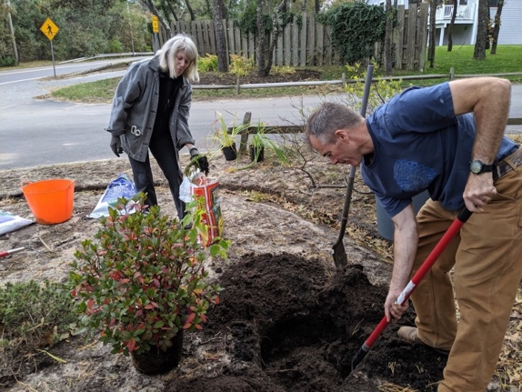

In addition to volunteering to be in charge of our roads, Bill Howell donates time to making our entryway attractive. Here he is working with Nan Bacon who helps design and put in new plants.

**Our Harbormaster**

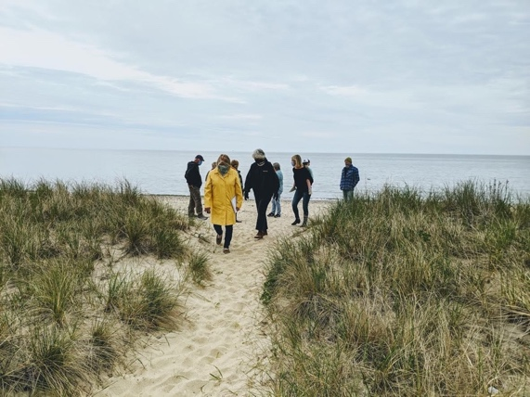

Our harbormaster, Alley Moore, shoulders not just the assignment of slips and the collection of funds which go into our community coffers but also the tricky waters and currents of the laws that allow us to dredge our channel and maintain our beaches. Our dredging permits will expire this year and renewing them can be complicated. Alley met with the Oak Bluffs Conservation Commission early in the spring (photo at left) to renew the needed permits for several more years. The harbor has been dredged and is now open for business and Alley is also working on getting a south dock piling realigned and pile driven.

**Farm Pond Turtle**



On June 6, Nan Bacon’s landscaper took this photograph of a snapping turtle inspecting the grounds around her new home at 50 Farm Pond Road. Your editor sent the photo to Chuck Fisher, the Oak Bluffs Shellfish Warden, and here’s what he says: “hard to see on my phone but it does look like a snapping turtle. I have occasionally seen them around the pond since I was a kid. They lay a clutch of 15 and up to 50 eggs around this time of year. Interesting thing is they don’t need to mate annually, females can store sperm for a couple years. If you see them it’s neat to leave them be.”

*Editors comment: REALLY! Females can store sperm for a couple years? What fun is that?*

**Clambake**

The date and time for our clambake this year is uncertain. Our clambake committee includes Linda Hellstrom, Jessica Baxter and Nan Bacon. They will monitor the unfolding situation and keep you informed. Hopefully a final decision can be made no later than mid-July. In the meantime, you might enjoy this time-lapse video (it’s a riot) of setting up the bake. <https://www.youtube.com/watch?v=f9RtL7Mxi-8>

**Annual Meeting**

*A message from Al Woollacott our Association president.*

Our bylaws require us to hold an annual meeting on the Saturday closest to July 4th. Currently, State regulations prohibit a gathering in the numbers that we have achieved at past annual meetings. So, we will conduct the meeting’s business – approving the proposed fees and budget, electing Officers and Directors, and voting on a bylaw amendment via e-mail.

Gathering (at EL Edwards’s house of late) and renewing friendships was the main reason many attended. “How was your winter?” was a frequently asked question among meeting attendees. We need to maintain that important aspect of our community this summer. Regulations change frequently as the country learns more. We may be permitted to gather in an open space like the beach and socialize later in the summer.

**Slow Down!**

Our roads are now graded and, unfortunately, are like a boulevard; please don't drive like you’re on a boulevard just because the roads are now pothole-free. Our speed limit is 15 MPH for several reasons. Dust always has been a major problem. If you see a rooster tail of dust in your rearview mirror, you are speeding -- slow down. Our narrow roads with heavy vegetation close to the edge limit sight-lines - severely so in certain areas. If you have ever swerved because an oncoming vehicle suddenly appeared, then either you, or the other vehicle, or both of you were speeding. Elderly Harthaveners walk our roads and lack the agility of their youth. They may be unable to move quickly away from a speeding vehicle. And young children will always run into a road without looking. If you have renters, forward this email to them. Make them, those who are working for you, your UPS and FedEx drivers, and others aware of our 15 MPH speed limit. Thank you for your consideration. Al Woollacott

**Kayaks, Canoes a Broken Paddle**

Five kayaks, a canoe, a beaten-up kayak paddle, and one canoe paddle are at the harbor. I have ordered three kayak paddles and two canoe paddles which Amazon promises to deliver on June 15th. A yellow kayak and blue kayak are at the harbor, too. They are not Harthaven's so please don't use them or the nearby paddles. Al Woollacott

**Over the Bar**

*It is with great sadness and an enduring sense of loss that we honor the lives of two stalwart members of our community who have passed away. Both were long term residents, and both were leaders of our community, contributing thousands of hours of time during their lives to foster and protect Harthaven.*

**David Garland Dutton Jr.**

David Garland Dutton Jr. passed away on Jan. 20, 2020. He was 93 years old.

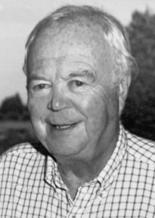“David has been an integral part of the fabric that is Harthaven,” wrote our Community Association President, Al Woollacott. “He served as the Community Association's President for many years. As Treasurer, I was fortunate to work with him during the 1990s. His calm, easy-going demeanor was infectious - a man you just couldn't help but like.  After he 'retired', he was always available to offer sage counsel whenever you needed it, a plentiful commodity with which he had been blessed. Seemingly ever-present during the summer as he drove his motor scooter around Harthaven, I would kid him, "Making the rounds, Dave?" He would chuckle and let me know that all was well. As his eyesight deteriorated, he gave up the scooter yet still patrolled the community on foot, which he eventually had to give up, too. His mind remained sound even as his eyesight failed him further.”

David’s life began on May 31, 1926, in Springfield, the first of four children born to Constance Mumford and David G. Dutton. Soon after, they moved to Poughkeepsie, N.Y., where Dave’s father was president of the A.C. Dutton Lumber Corporation, a family business with facilities up and down the East Coast, and one of the first businesses to pressure-treat wood products.

Dave attended the Poughkeepsie Day School and, subsequently, the Hotchkiss School in Lakeville, Connecticut. Upon graduation, he joined the Navy’s V-5 Aviation Training Program and was sent to Wesleyan University to continue his training. While in the Navy, he served on the USS Raymond as well as the USS Silverstein. When the war ended, he was discharged, and attended Williams College for further education.

In 1949, Dave met Barbara McDowell on the shore of Cream Hill Lake in Cornwall, Connecticut. Their attraction was instantaneous and lasted for more than 70 years. Married in July, 1950, they would eventually raise four sons: David, Allan, John, and Robert. In the late 1960s and early ’70s, the family split their time between Poughkeepsie and their beloved Vineyard home in Harthaven. During those years, Dave was elected as leader of the NBMDA, a national lumber wholesalers association, while serving as president of the Dutton family business, which was eventually sold, giving him the ability to move his family to the Vineyard year-round.

In 1976, he started an Island business based on what he knew best: building materials. Islanders will remember him best as the owner of Dutton’s Home Center (“Do Something Constructive”), located on State Road in Vineyard Haven. For two decades, he regularly dispensed wit and wisdom, and the store became a place where people would come to hang out, pick up building supplies, get a DIY lesson, or enjoy a story.

Throughout his life, Dave explored his many interests. In the 1960s he earned a pilot’s license and flew his single-engine Cessna airplane in and out of Tradewinds Airport in Oak Bluffs. Dave was a dedicated casual golfer, elected to the Oak Bluffs finance committee, and was a one-term president of the Harthaven Community Association. After selling the Home Center, Dave took to traveling in an RV, earning the moniker of “Camper Dave,” regularly visiting Nova Scotia, but also taking journeys West, making it to both Alaska and California.

Dave is survived by his wife Barbara and their four sons, David (and wife Renee and son Stanley) of Vineyard Haven; Allan (and wife Bianca and son Allan Lourden) of Harthaven; John (and daughter Chloe) of Las Cruces, New Mexico; and Robert (and wife Molly Conole and children Amelia and Simon) of Oak Bluffs. 

**Allen Hoyt Pease**

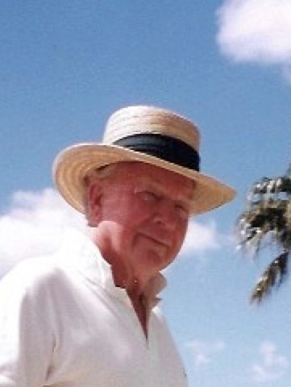“Al Pease brought great warmth to our community,” writes this newsletter’s editor, “I remember most clearly the annual feasts that we celebrated at his Harthaven home. He loved to cook and entertain and infused those events with his enduring goodwill along with good food. He provided a place and time for us to share and reaffirm our friendship with each other as neighbors and, often, family.”

Allen Hoyt Pease, 94, died Tuesday, February 11, 2020, at the Fisher House in Amherst, Massachusetts. He was surrounded in his last week by his family and his faithful wife and companion, Deborah Pease. Allen, known to friends as Al, was born on June 15, 1925, in New Britain, CT, the son of the late Maurice Henry Pease and Barbara Moore Pease. He is predeceased by his son, Randall Stuart Pease; and Randall’s infant twin, Maxwell Carpenter Pease; his sister, Martha Pease Bronson; and his brothers Maurice Henry Pease, Jr., and Lawrence Herbert Pease.

Al grew up in New Britain, CT, and attended Mooreland Hill School and Forman School, where he founded the Fig Newton Four, a quartet in which he played the drums.  After graduating from Forman, Al enlisted in the army in 1943, fighting in World War II, and in the Battle of the Bulge. He married Beverly Knight in 1947 and attended the University of Chicago receiving a B.A. degree. Al and Beverly moved to Charlottesville, VA where Al attended the University of Virginia School of Law and was on the law review. Following graduation, Al and Beverly moved, with their growing family, to Kensington, CT, where he established his tax and estate law practice, and was active in church and community service, including serving as a trustee for the New Britain Museum of American Art until his retirement. Al was also a dedicated member of the Harthaven community on Martha’s Vineyard, becoming the clerk for Hart Realty Association and serving as both legal advisor and friend to many in that community.

After his marriage to Michelle Revenaugh in 1985, Al spent his spare time renovating and sailing his Herreshoff NY 50 sloop and traveling. After Michelle died, Al met Deborah Carey in 1994, who would become his lifelong love; they married in 2003.  When they weren’t traveling, Al and Debby split their time between their Leverett, MA home and their home on Martha’s Vineyard. Each year the couple hosted a large beach gathering on the Vineyard, cooking for some 200 guests. The “Beach Party” became a well-known Harthaven tradition. An accomplished skier, sailor, and golfer, Al was also an excellent cook and a wonderful companion.  Al and Debby were gracious hosts to the many guests who visited them over the years. Generosity was second nature to the couple, who loved entertaining.

Al is survived by his wife, Deborah Pease of Leverett, MA; by his children, Allen Hoyt Pease, Jr. of Hebron; Marion Pease Berman of Madison; and Carol Lewis Pease of Kensington; and by his stepdaughter, Merritt Carey of Yarmouth, ME; their spouses; and his twelve grandchildren; and his three great-grandchildren. In lieu of flowers, donations may be made to the New Britain Museum of American Art or the Herreshoff Museum.

**Connection**

**By Sam Low**

Confined by the

Great Sickness

We

The fortunate few

Turn outward

Seeking Comfort

A simple Hello

A Smile

From an old Friend

**Final Notice to order Harthaven Hats**

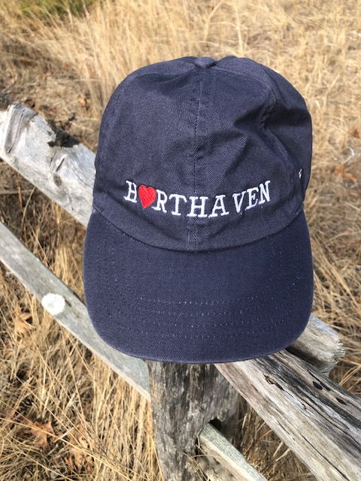

The Company that embroiders the attached logo Harthaven hat is now re-opened. Each hat is $24.00 each. Any shipping from MV to Residents is extra or it can be picked up at my house.  Payment must be pre-paid ASAP – ORDERING SOON. Delivery Mid-end July, check payable to Ron Moore. Email me – [moorevineyard@yahoo.com](mailto:moorevineyard@yahoo.com)

**Thankyou Community Volunteers**

*From the editor:*

On my daily walks around Harthaven it becomes more obvious how much this community relies on the unselfish efforts of others to keep things going. On the beach, I saw Alley Moore leading a tour for a dozen or so representatives from the Oak Bluffs Conservation Commission. At the entrance to our community, I saw Nan Bacon and Bill Howell tending to the plants and later I observed Bill driving around the community to survey the roads and make plans for their repair. Not so obvious were the efforts of Al Woollacott, our Community Association president and treasurer, laboring over his spreadsheets and tending to the daily business of the Association.

Thanks go to the Harthaven Community Association board who assist Al - Bill Howell, Vice President; Peter Pease, Clerk; members Alison Carothers, Art Stafford, Diane Morgan, Jed Hellstrom, Ron Moore and Sam Low.

And thanks also to the William H Hart Realty officers and board: Wesley Brown, president; Stephanie Mashek, vice president; Peter Pease, clerk; Al Woollacott, treasurer; Jennifer Benefit; Adrienne Boardman; Gina Cenkl and Andrew Moore.

Let’s take time to thank these neighbors personally as we encounter them in the daily rhythms of our lives.

**Thankyou Herald Contributors**

*From the editor*

You have all submitted thoughtful and well written articles that express your love for this island and this community. You have tickled the cockles of my soul. I love the in-depth pieces you have created and I love the new feature “Community Currents” in which you have submitted short pieces on your various activities. We are an inclusive community composed of many different personalities, all of them caring individuals. Thank you for celebrating “us.”

**SHARE YOUR NEWS**

***Please send short and long pieces now – right now - for the next edition.***

The **mission** of the Harthaven Herald is to support and enhance our neighborhood’s deep “sense of place” and of community.

**Tell us** about your work and your play, your family, your travels, adventures and other stories, editorialize, send your poems, your thoughts...

**This is your newsletter!**

**Please send articles, announcements, greetings, ideas – whatever – to me**

**Sam Low, your editor at:**

[**Samfilm2@gmail.com**](mailto:Samfilm2@gmail.com)

**Cover Art:** the painting on the first page is believed to be by James A. Lawless. From his website: “The artist, born in 1949, spent his childhood among sailboats on the waters of New Jersey's Toms River and Barnegat Bay. While pursuing a veterinary career, this primarily self-taught artist, experimented with various media, including acrylics, water colors, oils, pencil & ink and snow and sand sculpture. For two years he lived on Martha’s Vineyard concentrating on painting the land and seascapes that make this island oasis so alluring to the artist seeking luminosity. He has studied under the late contemporary realist Dominique Rickard and renowned marine artist Don Demers and is strongly influenced by the works of John Stobart and Richard Schmid.”